Einstein’s Rotating Disk Thought Experiment:

The link between Special and general relativity

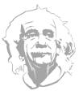Albert Einstein had a powerful imagination and was famous for “thought experiments”: if “A” is true and “B” is true, then a bit of careful thought reveals that “C” must also be true, where “C” often turned out to be some amazing, deep new insight into the hidden “gears and wheels” at work in our universe. Perhaps the most beautiful of these is his “rotating disk” thought experiment (circa 1907), which played a crucial role in his development of the ideas that eventually led to general relativity—his revolutionary theory of space, time and gravity (1915).

As most people know, general relativity superseded Isaac Newton’s model of gravity. Gravity is no longer thought of as some sort of “force” acting between objects. Following Einstein, physicists understand gravity as a beautiful manifestation of the warping of the geometry of space and time. But wasn’t Newton’s model of gravity brilliantly successful for 250 years? Yes. So why do we need another model? There were basically two facts that knocked Newtonian gravity off its pedestal:

1. Experimental: Newtonian gravity fails to correctly predict the observed orbits of the planets, in particular the planet Mercury. The predictions are quite good, but careful observations in the 19th century revealed slight discrepancies that no one could find a way to resolve. General relativity resolved these discrepancies.
2. Theoretical: Newtonian gravity is not compatible with Einstein’s idea that our universe has a speed limit: no material object or information of any kind can travel faster than 299,792, 458 m/s (about 1 billion km/hr). For instance, at this speed it takes about 8 minutes for light to travel from the Sun to the Earth. So if the Sun were to suddenly disappear, the universal speed limit forbids us any means of knowing of this catastrophe until 8 minutes later. Light itself respects this required time delay: the Sun would continue to blaze in our sky during the whole 8 minutes it takes the last ray of light from the Sun to make its journey to the Earth. Only *then* would the Earth be plunged into darkness. Newton’s model of gravity does *not* respect this required time delay: it predicts that at the same instant the Sun disappears, the “gravitational force” it exerts on the Earth would also disappear, causing the Earth to immediately break out of its usual orbit. Observers on night side of the Earth could be immediately aware of this catastrophe by noticing a change in the apparent motion of the distant stars produced by the change in the Earth’s motion. General relativity resolved this problem.

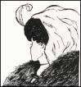Einstein recognized these problems and the need for an improved model of gravity. But when he began his quest he did not realize how radically different from Newton’s model it would turn out to be! At its conceptual foundation, Einstein’s geometrical model of gravity is diametrically opposite to Newton’s force model. Understanding the basic idea is very much like having first seen the beautiful young woman in this famous Gestalt picture and then later, suddenly seeing the old woman, who was there all along but you just weren’t looking at it in the right way. Can you see both?

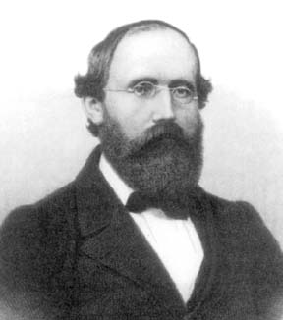We will begin by introducing the gravitational analogue of this Gestalt picture, called Einstein’s “equivalence principle”. Taking this equivalence principle seriously, together with some earlier ideas about the nature of space and time he had learned from his work on the theory of special relativity (1905), Einstein devised his ingenious rotating disk thought experiment. The result was strong motivation for the idea that, whatever gravity is, it is very likely to be intimately connected with a warping of space and time (or spacetime, for short). This was not an entirely new idea: in a landmark lecture delivered on the 10th of June, 1854, the great mathematician **Georg Friedrich Bernhard Riemann** (see picture) asked the question: might the *space* we live in be warped? The question was half a century ahead of its time. Unaware of Riemann’s question, Einstein asked if *spacetime* (not just space) might be warped. And unlike Riemann, Einstein provided also a strong physical motivation for the idea. At this time Einstein was not particularly mathematically inclined, but armed with this new insight Einstein learned of Riemann’s ideas and laboured to understand the mathematics he had developed. Out of this, general relativity was born. It is a rich and fascinating story, but in this essay (Part I) I will focus only on how Einstein arrived at this tantalizing potential connection between gravity and warped spacetime.

**Weightlessness**

Let’s start by imagining that NASA has constructed a space station in the shape of a giant soup can, and this soup can is freely floating in an orbit around the Earth (I know, a soup can is not as cool-looking as the International Space Station, but work with me…). We fill up this giant tin can with air and imagine our intrepid astronaut Alice floating around inside, weightless just like astronauts floating around inside the space shuttle. Let’s first remind ourselves what “weightless” means.

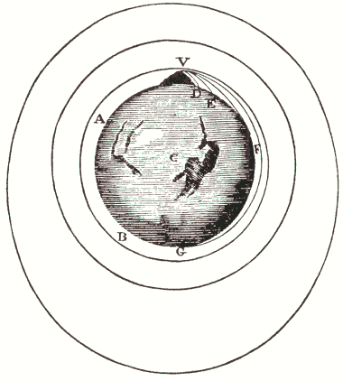Newton came up with a beautiful argument to imagine how an object such as the Moon orbits the Earth. The illustration at right is from his book, the *Principia* (1687), one of the most important and influential books ever written. Imagine standing at the top of a mountain and throwing a rock straight out, in a direction horizontal to the Earth’s surface. The rock will describe a curved trajectory that takes it some distance away from the base of the mountain before it hits the ground. If we throw the rock harder, it will travel a further distance before it hits the ground. We can easily imagine throwing it hard enough to make it go all the way around and hit the Earth at the base of the mountain. Throwing it harder still, we could even imagine it circling the Earth several times before hitting the ground (we are ignoring air resistance!). Of course if we throw it *too* hard (faster than about 40,000 km/hr), it will actually escape Earth’s gravitational field never to return—what goes up does *not* always come down! So there must be some speed less than this (it turns out to be about 28,000 km/hr) for which the rock will circle the Earth and return to exactly its starting point (and hit us in the back of the head if we’re not careful), whizzing by us with exactly the same speed it had when it was first thrown. (At this speed it takes about 84 minutes to travel around the Earth). So what will it do now? It will simply go around again, exactly as before, and again, and again: the rock will be in orbit around the Earth, at an altitude equal to the height of the mountain. The European Space Agency Web site has a nice animation of this.

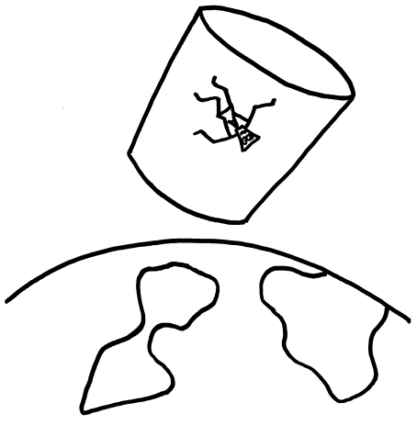What has this got to do with weightlessness? Instead of one rock, imagine throwing two rocks, side by side, both initially moving in the same direction. Both will travel along separate orbits, but they will always remain close to one other (actually, the orbits will cross each other twice before the rocks return—can you see why?). Standing on one of the rocks, we would see the other rock simply floating nearby—just “hanging in space”. Now imagine that one of the rocks is an astronaut and the other is the space shuttle. It should be clear now why astronauts float “weightless” inside the space shuttle! The same thing applies to Alice in our big tin can.

**Artificial Gravity and the Equivalence Principle**

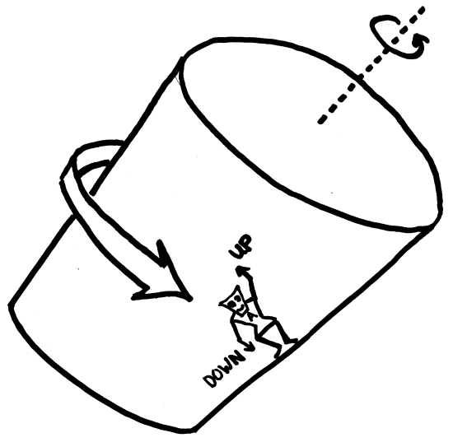Now, as a space engineer you have been given the task of creating an “artificial gravity field” in this space station so that Alice and her comrades can work in a normal gravity environment like on Earth. How will you do it? Simple: make the big tin can rotate on its axis! Just like in the notorious “spinning cylinder” amusement park ride in which you go round and round and the floor drops out from beneath you, Alice will be “stuck” to the outer wall of the rotating space station. It will *feel* to her as if there is some mysterious “force” pushing her against the wall. Moreover, rather than lying flat with her back against this wall, as in the amusement park ride, she can stand up so that the wall is now the floor! As far as gravitational effects are concerned, standing on this floor would feel no different to her than standing on the surface of the Earth. She could also walk around on this floor normally as if she were walking on the Earth.

The important question to ask now is: Does Alice’s experience of this “artificial” gravity effectively mimic the features of “real” gravity she experiences when standing on the Earth? Actually, yes. To help see this, imagine that Alice is holding an apple in her hand. If she were standing on the Earth she would feel the apple’s “weight”, which appears to be due to some sort of mysterious “gravitational force” pulling the apple to the ground. Since the idea of gravity as a force is in question here, let’s describe this situation without reference to “weight” or “gravitational force”. We can simply say*: to keep the apple from falling to the ground Alice finds that she must exert an upward force on the apple*. Certainly this much is true. Imagining, in *addition* to this, there is some sort of gravitational force at work is unnecessary and, in fact, wrong.

To see this, let’s now transplant Alice and her apple to the rotating space station. Taking a top view of the situation we can see that when Alice is holding the apple in her hand, the apple—like Alice—is moving in a circle. The law of inertia tells us that any object always wants to move in a straight line at a constant speed, and any deviation from this natural state of motion requires a force of some kind acting on the object. So, since the apple is moving in a circle (which is not a straight line) there must be some force acting on it! And a bit of thought tells us that this force must be directed towards the centre of 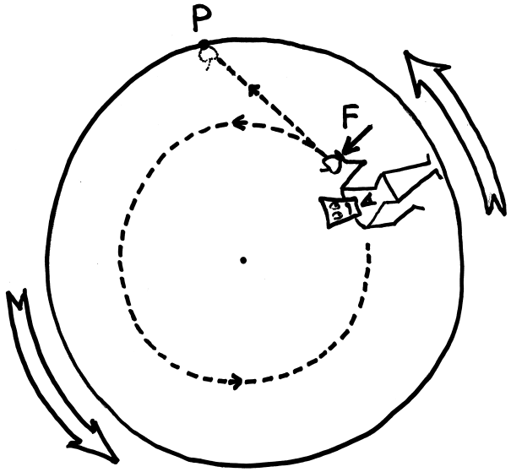the rotating cylinder (always perpendicular to the path; always pushing the apple sideways, off the straight line path it wants to go on). But where is this force coming from? Alice’s hand, of course! Alice finds that: *in order to hold the apple in place she must exert an upward force on it* (force F in the figure; “upward” in this case meaning towards the centre of the rotating cylinder). She could interpret this as a force required to counterbalance some mysterious “gravitational force” tugging on the apple, i.e. the apple’s “weight”, or she could see it for what it is: *the force required to continuously push the apple off its straight line, inertial trajectory (line from her hand to point P), making it move instead in a circle*.

To further clarify this, suppose she now pulls her hand aside and lets the apple “fall”. At the instant she removes her hand the force she was exerting on the apple disappears. With no force acting on it, the apple is no longer compelled to move in a circle and it instantly begins moving on an inertial trajectory: the apple continues its motion along a straight line path with the speed and direction it had at the instant it was released (line from her hand to point P). After a few seconds on this force-free trajectory, the apple runs into the wall of the rotating cylinder (at point P), i.e. it hits the floor at Alice’s feet. (Note that during the apple’s free-fall, Alice continues to rotate around so that her feet reach point P at essentially the same time the apple does.) To sum up: Alice finds that when she lets go of the apple it falls to the floor, in exactly the same way it would if she were standing on the Earth witnessing the effects of the Earth’s gravitational field.

Moreover, if you study the diagram carefully you will see that from Alice’s perspective the apple *appears* to be *accelerating* (moving ever faster towards the floor), just as an apple accelerates when it falls towards the Earth. To see this, observe that near the beginning of its trajectory, just after it is released, the apple is drifting through space in almost the same direction as Alice is moving, so from Alice’s perspective the apple will appear to be almost hovering in space, falling only very slowly. But later, near point P, Alice’s trajectory is no longer parallel to the apple’s trajectory. In particular, the trajectory of her feet (which follows the curve of the rotating cylinder) has curved around so as to now be on a rapid collision course with the apple. So although Alice sees what appears to be an accelerating apple, just as she would in a real gravitational field, what’s actually going on is quite the opposite: it is *Alice* who is accelerating, not the apple; *she* is the one moving on a curved trajectory that eventually intersects the apple’s straight, non-accelerated, force-free trajectory.

Thus we come to the Gestalt picture I referred to at the beginning:

Newton said that a falling apple is *accelerating*. Since acceleration requires a force, Newton had to invent the idea of a gravitational force that tugs on the apple while it is falling, making it fall faster and faster. Einstein said that it is precisely when the apple is falling that it is *not* accelerating (straight line trajectory in our space station example), and there is no need to introduce a mysterious gravitational force.

Newton said that an apple in your hand is *not* accelerating. No acceleration means no force. To arrive at no force, Newton imagined two *exactly counterbalancing* forces at work: gravity pulling the apple down and our hand pushing it up. Einstein said there is only *one* force at work: our hand pushing it up. This “unbalancing” force causes the apple to veer off its natural trajectory (and move instead on the circular trajectory in our space station example).

In short, what Newton got backwards was *when the apple is accelerating and when it is not*. This false starting point, although it is the common sense one, led him astray and required him to invent the idea of a gravitational force. Einstein took the diametrically opposite perspective, which showed “gravitational force” to be a red herring. What we have been discussing is an aspect of Einstein’s “equivalence principle”, which in this example amounts to the inability for Alice to distinguish in any way between the following two situations:

1. She is inside a *rotating* space station, holding an apple in her hand. The force she is applying to the apple is required to counter the apple’s *inertia* (natural tendency to move in a straight line) and make it move in a circle.
2. She is inside a *non*-rotating space station, holding an apple in her hand. The force she is applying to the apple is required to counter the apple’s *weight* (the “gravitational force” exerted on it by other masses, which she presumes exist somewhere outside the space station).

(Of course we are imagining that there are no windows for Alice to look out of to see if the stars are rotating or not!) The subject of Einstein’s equivalence principle is very rich, and just exactly what he meant by it is still a topic of scholarly debate amongst historians of science, not to mention plenty of current research scrutinizing its validity (both experimental and theoretical) in a variety of tricky contexts. I will not pursue the discussion further here.

But there’s still a crucial piece of the puzzle missing. While Einstein’s position makes sense in our little rotating space station example, how is it supposed to make sense for *real* gravity? Remember, what Einstein is saying is that when you are standing on the Earth holding an apple in your hand, the force applied by your hand is causing the apple to *continually accelerate*. And yet it *appears* to be very much at rest! It is easy to see how this is not a paradox in our rotating space station example: from Alice’s perspective the apple is, indeed, at rest—she is holding it in her hand—*and yet* it is actually continually accelerating since it is moving in a circle. But it is not so easy to see what’s going on when we transplant Alice and her apple to the real gravity situation on the surface of the Earth. The “at rest” part is easy to see, but the “continually accelerating” part is not. It took the genius of Einstein to make sense of this—to see that what is involved is a warping of space and time. *How* Einstein realized that gravity is likely associated with a warping of space and time is the subject of this essay (Part I). In Part II we will see how the idea of warped space and time resolves the puzzle of “apparently at rest and yet continually accelerating”. So let’s now return to Einstein’s rotating disk [rotating space station] thought experiment to learn how he arrived at the idea of warped space and time.

[Incidentally, I invite the reader to imagine other experiments Alice could perform that might distinguish her experience of this “artificial” gravity from “real” gravity on Earth. For example, will a balance scale work the same in this artificial gravity as it does on Earth? What about a weigh scale? From Alice’s perspective, will a pitched baseball travel along a parabolic trajectory? What about the beam of light from a flashlight? These are all interesting questions worth pondering if you wish to get a better feel for Einstein’s perspective on gravity.]

**The Warping of Time**

Einstein started with two simple facts about the nature of space and time (in the absence of gravity) that he had discovered through his development of the theory of special relativity. The two facts are “time dilation” and “length contraction”, which led him to warped time and warped space, respectively. These are fascinating effects in their own right, but I will not attempt to explain them in any detail since there are plenty of excellent references on special relativity. I will simply describe *what* these effects are, and move on to the more interesting discussion of their consequences for the nature of gravity.

Let’s begin with time dilation. Imagine that Alice and her friend Bob have identical watches. Standing next to each other, they synchronize the pair of watches to read exactly the same time. As a double check that everything is in order, they hold the watches side by side and observe that they are ticking at exactly the same rate. Then, at exactly 12 noon according to both watches, Alice leaves and goes for a walk around the block. When she returns and they compare watches, the time showing on Alice’s watch will be a fraction of a second *behind* the time showing on Bob’s watch. They are surprised! So they check again, and sure enough both watches are ticking at exactly the same rate, just as before, but Alice’s watch reading is now slightly *behind* Bob’s. How is this possible? It must have something to do with her *motion* relative to Bob. It is important to realize that her motion is not in any way affecting the mechanical mechanism inside her watch. Rather, because of her motion, time *itself* is moving more slowly for Alice during her walk *relative* to the rate at which time is moving for Bob.

Would Alice have been aware of this slowing of time? No! In no way can Alice “feel” this slowing of time. For example, suppose both Alice and Bob have heart rates of exactly one beat per second when they are standing next to each other. Along her walk, if she bothered to measure, Alice would have found that her heart continued to beat exactly once per second (seconds according to *her* watch; also, we are assuming that the exertion of walking does not affect her heart rate!). In fact everything about her: her biological clock, her speed of thought, or any other conceivable measure of time, is exactly in synch with her watch. She doesn’t notice *anything* out of the ordinary until she arrives back at Bob’s side. It is only when they compare watches that they realize something strange must have been happening during her walk. On comparing watches they both agree that Alice has, for some reason, experienced less elapsed time than Bob; her heart has beat fewer times than Bob’s; she has actually aged less than Bob during her walk. Her walk has, quite literally, transported her into Bob’s future!

Of course the effect is quite small for a situation like this, but it can be dramatic if we imagine, instead of Alice going for a walk around the block, getting into a very fast spaceship and making a round trip to a distant star and back. Suppose the trip takes, say, twenty years according to Bob. It may take only a few days or less for Alice, depending on how close to the speed of light her spaceship was moving. This is the famous “twin paradox”, which is not a paradox at all—it is easily understood within the framework of the peculiar geometry of spacetime that Einstein discovered (actually, the mathematician **Hermann Minkowski** was responsible for pointing out the interesting type of spacetime geometry that lies behind this and other effects). This time dilation effect is easy to observe experimentally using accurate atomic clocks, and is universally accepted as a basic—albeit somewhat strange—property of our universe. The really interesting thing is to now follow Einstein’s train of thought and apply this basic fact in the context of our rotating space station to see what we can learn about the nature of gravity.

So let’s imagine that Alice and Bob have identical watches as before, with Bob floating freely “at rest” outside the space station (he is in a spacesuit doing a spacewalk), watching Alice revolving round and round inside the spinning space station. As Alice comes around, she puts her watch up against the window and at the instant she passes by Bob, he sets his watch to read the same time as hers. She then continues around once (just like walking around the block) and the next time they meet Bob looks at Alice’s watch through the window and notices that *less time has elapsed for her than for him*. Time is moving more *slowly* for Alice than it is for Bob, although, as emphasized earlier, she herself does not experience anything out of the ordinary. It’s only when they *compare* watches that they both notice something strange is happening.

The effect becomes increasingly dramatic the faster the space station spins. If the space station is spinning so fast that Alice is whizzing by Bob at nearly the speed of light, time is almost at a standstill for her *relative* to Bob’s experience of time. In fact, because of this, the rotating space station can be used as a time machine for traveling into the future. Suppose that Alice and Bob are both 20 years old, and one day she climbs into the space station and stays there for 30 years according to Bob. According to Alice, maybe only 30 days or 30 minutes has passed for her, depending on how fast the space station is rotating. She climbs out of the space station still 20 years old, but finds a 50 year old Bob, and indeed a whole universe that is 30 years into the future of the universe she knew. From Alice’s point of view, she simply climbed into a strange spinning contraption, sat there for 30 minutes, say (albeit in a *very* strong gravitational field), and climbed out to find that she has travelled 30 years into the future!

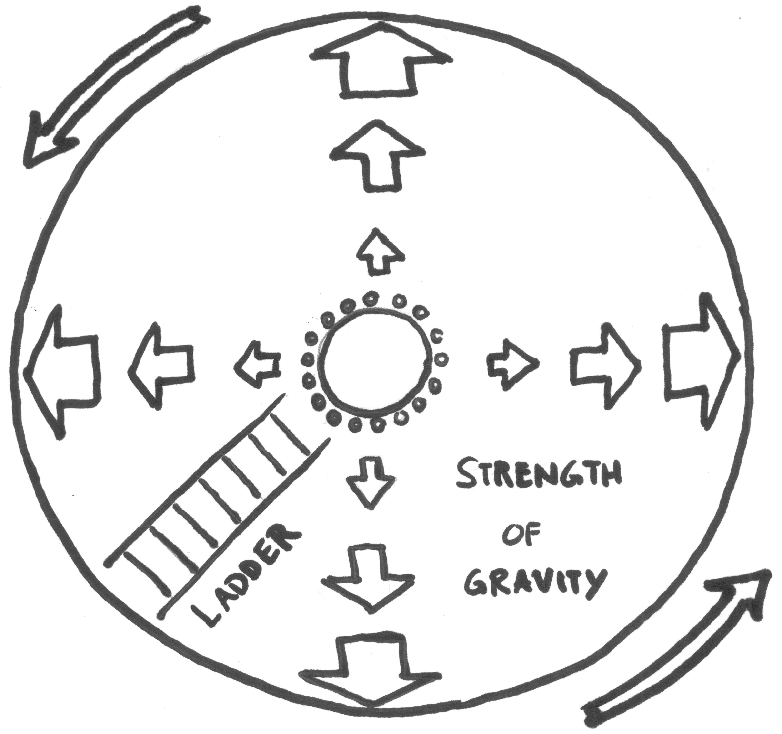So what does this tell us about the nature of gravity? Einstein’s thinking went like this: Let’s forget everything we think we know about gravity and start from scratch. The slowing of time effect in this *artificial* gravity example is clearly a special relativity effect (time dilation) associated with Alice’s *motion* (*rotating* space station). But according to the equivalence principle, Alice is equally entitled to consider herself to be *at rest* (*non*-rotating space station) in a *real* gravitational field produced by some masses existing somewhere outside the space station. If there really is no way for Alice to tell the difference between these two situations, then whatever properties she notices about *artificial* gravity must also be true of *real* gravity. Thus Einstein was led to the idea that *gravity, whatever it is, is likely to be intimately connected with a slowing of time*.

Can we test this? Well, suppose there is a ladder leading from a point on the floor to a hatch at the centre of the top of the cylinder. If Alice is standing on the floor, time is moving more slowly for her than it is for Bob because of her rapid circular motion. If she climbs up a few rungs of the ladder (moving *against* the “pull of gravity”), her speed of motion will be reduced (notice that this speed is zero at the top of the ladder). So the slowing of time relative to Bob will likewise be reduced (at the top of the ladder her time will be running at the same rate as Bob’s). In this way Einstein reasoned that *time might be expected to move at different rates depending on where a person is in a gravitational field*. In particular, time should move faster (i.e., less slowly) the higher up we are a gravitational field (i.e., the higher we climb *against* the “pull of gravity”).

Let’s apply this lesson to real gravity on the surface of the Earth. If Alice and Bob are standing side by side, their respective time is obviously moving at the same rate. If Alice now climbs to the top of a tower (moving *against* the “pull of gravity”), time should be moving more *quickly* for her than it is for Bob at the bottom of the tower. If she spends the day at the top of the tower and then climbs back down, she will have aged more than Bob by virtue of the fact that she spent some time in a part of the universe where time moves more quickly. The effect is quite small in Earth’s relatively weak gravitational field, but easily measured using accurate atomic clocks. In fact, the Global Positioning System, which relies on very accurate measurements of time intervals made by atomic clocks both here on the Earth and high above in orbiting satellites, must account for this gravitational warping of time in order to work properly. There is no doubt that this effect is real. It has been measured to great precision. What is amazing is that this effect was *predicted* by Einstein simply through the power of careful thought and imagination—through a “thought experiment”!

**The Warping of Space**

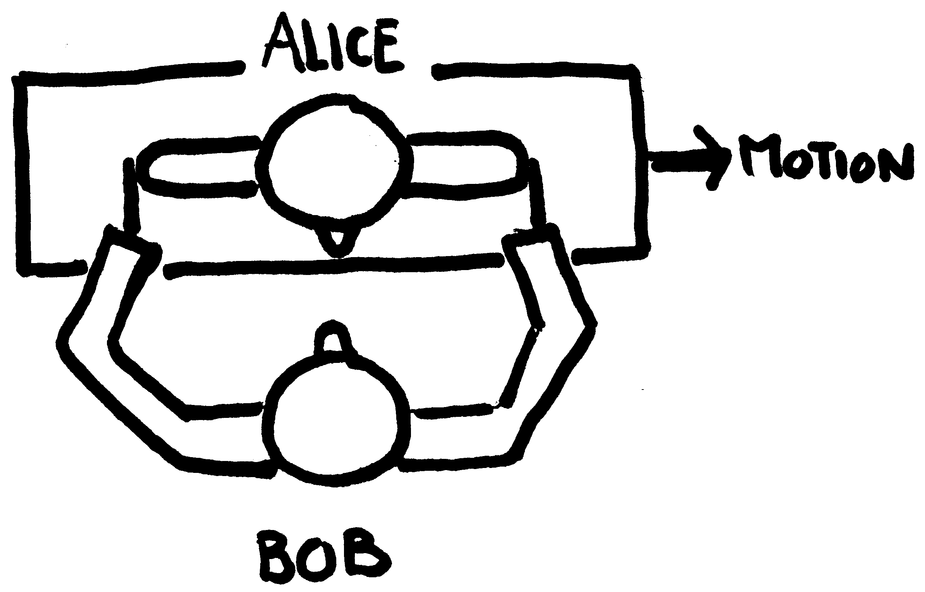Let’s now move on to our second example: the warping of space that accompanies a gravitational field. Imagine that Alice is standing on a platform with wheels that is rolling swiftly past Bob (to the right in the figure). Bob wishes to measure the width of Alice’s shoulders while she is in motion. How will he do this? At the instant she is passing in front of him he thrusts both hands forward such that, in that instant, he is touching both of her shoulders *at the same time*, one hand on one shoulder, the other hand on the other shoulder. Of course since Alice is moving, he can touch her shoulders in this way only for a split second before she moves on past his hands. He then carefully withdraws his hands, walks over to a metre stick, and measures the distance between his hands, which is the distance between her shoulders as far as he is concerned. The surprise is that the distance he measures in this way gets smaller and smaller the faster she is moving. The effect is difficult to measure for speeds we experience in everyday life, but becomes dramatic as Alice approaches the speed of light. Close to the speed of light, Alice will be paper thin according to Bob. However, it is important to realize that—just as in the case of time dilation—Alice herself experiences no such contraction. As far as she is concerned, she maintains the same ratio of width to height. No distortions. This effect is called length contraction, and has been verified experimentally to extremely high precision.

Before we go on to see the consequences of this effect for gravity, let’s try to understand a bit better what is going on here, simply because it’s really quite fascinating. Both length contraction and time dilation can be understood as simple consequences of something called “relativity of simultaneity”. It is a quirky fact about our universe that if Bob snaps his fingers on both hands simultaneously, the snapping of his fingers will *not* be seen as simultaneous to someone in motion relative to Bob. In our previous example, if Bob snaps his fingers simultaneously according to him, then according to Alice she will see *the fingers of his right hand snap first, followed by the fingers of his left hand*. Why? I won’t try to answer this here. So what? I will answer this: According to Bob, when he is measuring the width of Alice’s shoulders, his right hand is touching Alice’s left shoulder *at the same time* that his left hand is touching her right shoulder. These events, like the snapping of his fingers, are simultaneous according to Bob. But Alice does not experience them as simultaneous. What she sees is first Bob’s right hand thrusting forward to touch her left shoulder, followed shortly afterwards by his left hand thrusting forward to touch her right shoulder. It’s no surprise to her that Bob is measuring a shorter width. After all, between the times that Bob touches her left shoulder and touches her right shoulder, she has moved some distance to the right. Her *right* shoulder has moved closer to where her *left* shoulder *used* to be, so there is nothing really strange about Bob’s shorter measurement. (The situation is a bit more complicated that I have described, but this is the main effect going on.)

Notice that what’s happening here is delightfully bizarre: when Bob “reaches into” Alice’s “moving frame”, he *thinks* he is touching her shoulders at the same time (and in fact he *is*, according to *his* sense of simultaneity), but in fact his hands are touching two shoulders, *one of which is in the future of the other*, according to Alice’s sense of simultaneity! It is important to stress, however, that although we can understand *why* Bob’s measurement comes out smaller in terms of this relativity of simultaneity, it doesn’t remove the physically real fact that Alice *is* contracted in Bob’s frame—she really *does* occupy a lesser volume of (Bob’s) space!

So what are the consequences for gravity? Imagine that, when the space station is not rotating, exactly 100 Alices can be fit—shoulder to shoulder—around the inside circumference of the cylinder. And suppose we place 100 Bobs around the outside circumference of the space station, one Bob for each Alice. After the space station has begun to rotate, at one instant of time (simultaneous for all of the Bobs) each measures the width of the Alice immediately in front of them at that moment. Just as in the previous case of Alice gliding past Bob on a moving platform, each Bob will determine that his respective Alice is contracted in width. We still have 100 Alices, but each Alice is now thinner, so that 100 of them strung together no longer span the circumference. What actually happens as the space station begins to spin faster is that *gaps* begin to appear between the shoulders of the Alices. If the space station is spinning fast enough, each of these gaps will be wide enough to fit another Alice, so that we could now have 200 Alices standing shoulder to shoulder inside the space station!

Remember, as far as each Alice is concerned, no contraction whatsoever is happening. As mentioned before, each Alice always maintains the same ratio of width to height as measured by herself or anyone rotating along with the Alices inside the space station. What must be happening is that the physical circumference of the space station, as reckoned by people inside it, is growing! What started as a 50 metre jog around the space station when it was not spinning is now a 100 metre jog. It is important to realize that, just as it is time *itself* that is warped inside the space station, here it is *space* itself that is warped, relative to space as measured by the Bobs at rest outside the space station.

With this expansion of the spatial circumference, what happens to the metal skin of the space station? Same thing that happens with the Alices. A strip of metal that used to stretch 50 metres around the circumference when the station is not spinning is now being asked to stretch 100 metres around, which of course it can’t do. The metal would rip. So we need to either make the hull of the space station out of a flexible material that can expand, or we need to keep on welding in new sections of metal as the spatial circumference expands.

Notice that if the circumference is increasing, the physical volume of space inside the space station must also be increasing. And this effect is *real*. Suppose that, when the space station is not rotating, 10 thousand buckets of water could be poured into it before it is filled up. As the space station (and the water inside) begins to rotate, the physical volume of the space inside increases so that now *additional* buckets of water could be poured in from the outside. Although nothing changes on the outside—the Bobs outside see a rotating cylinder that always occupies the same volume of space—the amount of space *inside* is increasing; there is simply more *room* inside. Indeed, if the space station were rotating fast enough, so that the edge of the cylinder was moving at close to the speed of light, *an entire ocean worth of water* could be poured into the space station from outside! And if the rotation of the space station (and the water inside) was suddenly brought to a halt, the volume of space inside would suddenly shrink to its normal value and the ocean of water—which no longer has enough room—would suddenly explode into the surrounding space!

Using the same equivalence principle argument we discussed above for time warping, Einstein reasoned that *a gravitational field might be expected to be accompanied by some sort of warping of space*. And indeed, this is exactly what happens in Einstein’s theory of general relativity. Moreover, this effect has been observed in experiments. For example, consider a huge imaginary spherical surface in space, centred on the Sun, with a radius equal to the radius of the orbit of Venus, say. As an astronaut in a spaceship you could navigate the surface of this sphere and measure its surface area (tedious and time consuming, but doable). Knowing the surface area you could calculate what you might expect the volume of space inside to be (just like by measuring the surface area of a basketball you can figure out the volume inside by using elementary geometry). The difference from the basketball case is that the gravitational field of the sun warps the space around it in such a way that there is more volume inside the surface than you predict using elementary geometry. If instead of just hovering on the surface of this imaginary sphere you take your spaceship inside, and move around, you will find that there is more room in there than you expected. More stuff could be put inside. The space is *warped*. This effect has recently been measured very accurately using NASA’s Saturn-bound Cassini spacecraft.

So we have seen how Einstein was led to the idea that a warping of space and time might be somehow intimately connected with the phenomenon of gravity. This is, of course, only the beginning of a long and fascinating story. The next step is to understand how a warping of spacetime can resolve the puzzle of “apparently at rest and yet continually accelerating” that we mentioned earlier. We will discuss this in the ISSYP General Relativity Lectures.